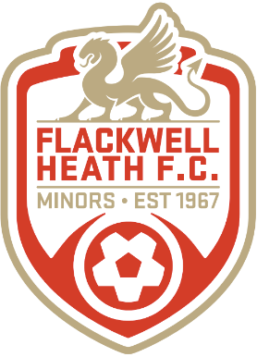 | Flackwell Heath Minors Football Club  Affiliated to Berks and Bucks Football Association

CLUB REGISTRATION FORM 2020/21

Please complete this form where applicable and return it to the Manager/Coach of the team you are applying to join/re-register, together with the appropriate fee.

Players Name: |  | Team: | Flackwell Heath Minors FC | Under: | 14 Scorpions

Date of Birth: |  | School: |  | School Year:

Parents/ Guardians Names: | Surnames: |  | Forenames:

Home Address: |  |  | Email Addresses:
Town: |  |  | Home Telephone Number:
Postcode: |  |  | Mobile Number:

Previous Club: (if not FHM) |  |  | No. of Years with FHM: (or new)

New Signings: Are you free from debt, bookings or suspensions from previous club? | Yes | No | Detail:
Parent/Guardian: Parent’s Permission for child’s photograph to be used for publicity or on FHM Website | Yes | No | Detail:
Parent/Guardian: Are there any Skills/Trades/Contacts that you are willing to share with the Club?  Would you or your company consider sponsoring the club? | Yes | No | Detail:

Declaration:
I agree to be bound by and to observe the club rules and the rules and regulations of the Football Association Limited and The FA, and all competitions in which the club participates. I have also read and understood the clubs Code of Conduct for parents and players on the club web pages and agree to abide by them. I agree to pay any disciplinary fines imposed (red or yellow card offences) on my child.
I confirm that I have read and understand the activities being offered to my child and agree with the measures the club has put in place to manage any risks, including its Covid-19 measures in line with current Government guidance.
By signing this form, I agree to my child becoming a member of Flackwell Heath Football Club.

Parent/Guardian Name (Print): | Sign: | Date:

